Rifles & Shotguns
- Enfield SMLE

History: Officially the Short Magazine Lee-Enfield Mk III*, this was the primary rifle of the British Empire. Adopted in 1907, it was the standard infantry weapon throughout the war and known for its reliability in trench conditions and high rate of fire by trained soldiers, who were often mistaken for machine gunners by the Germans.
  - Caliber: .303 British.
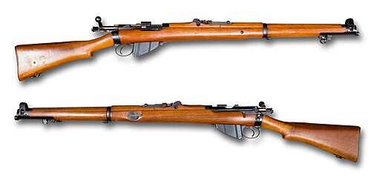
- 1897 Trench Shotgun
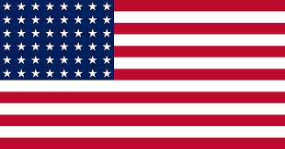
History: The Winchester Model 1897 pump-action shotgun was adapted for U.S. military use in 1917 for brutal close-quarters trench combat. Its ability to "slam-fire" (firing simply by holding the trigger and pumping the action) made it devastatingly effective, leading Germany to issue an official, though ignored, protest against its use.
  - Caliber: 12 gauge .00 buckshot (with a 20-inch barrel for the trench model).
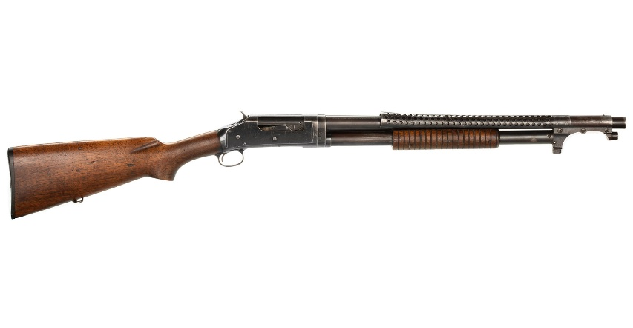
- P17 (Model 1917)
History: Officially the U.S. Rifle, Caliber .30, Model of 1917, it was an American modification of the British Pattern 14 rifle design. Due to a shortage of Springfield M1903s, the P17 was mass-produced and ended up arming roughly 75% of the American Expeditionary Force by war's end, becoming the most numerous U.S. combat rifle of the war.
  - Caliber: .30-06 Springfield (7.62x63mm)
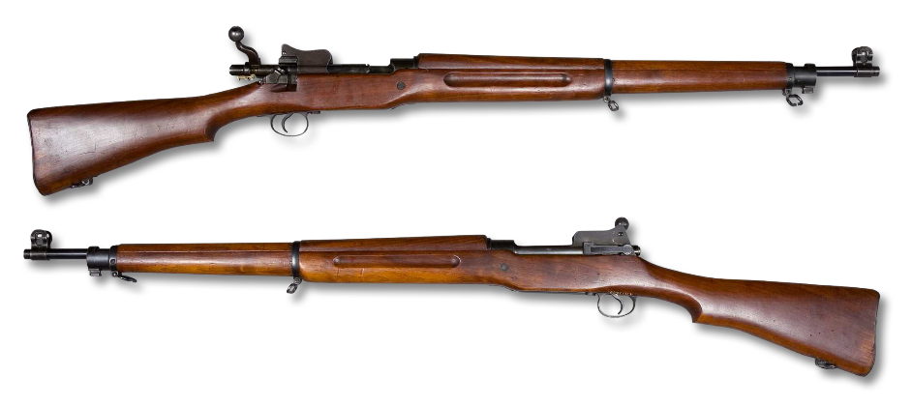
- Springfield M1903
History: The standard U.S. bolt-action service rifle at the start of the war, though ultimately outnumbered by the M1917 in the field. It was highly regarded for its accuracy and precision and remained in service as a standard and sniper rifle through several subsequent conflicts. German infantry were constantly amazed by the lethal range of this rifle, often inflicting casualties at over 500 yards.
  - Caliber: .30-06 Springfield.
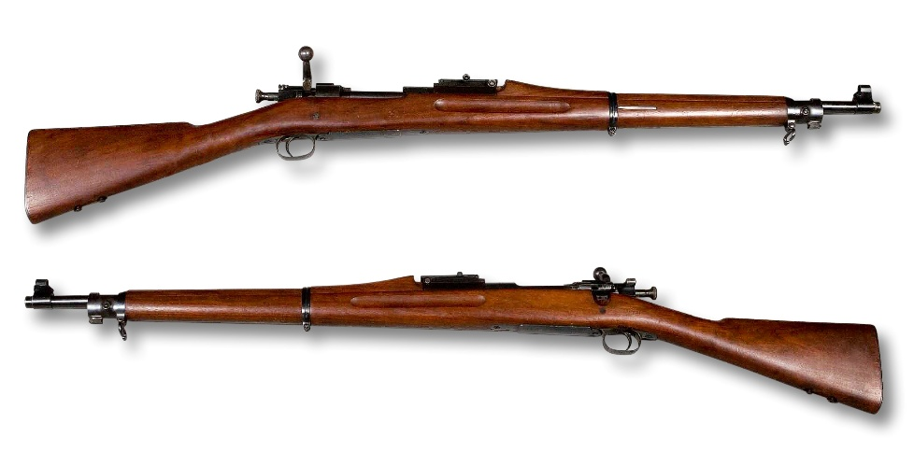

- Gewehr 98
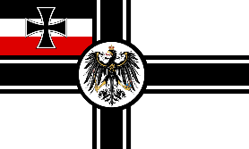
History: The standard German service rifle, renowned for its robust Mauser-designed bolt action and long-range accuracy. Introduced in 1898, it was a durable and reliable weapon used extensively by German forces throughout the conflict. It’s bolt action mechanism was one of the most copied designs in history, and is still in use today.
  - Caliber: 7.92x57mm Mauser
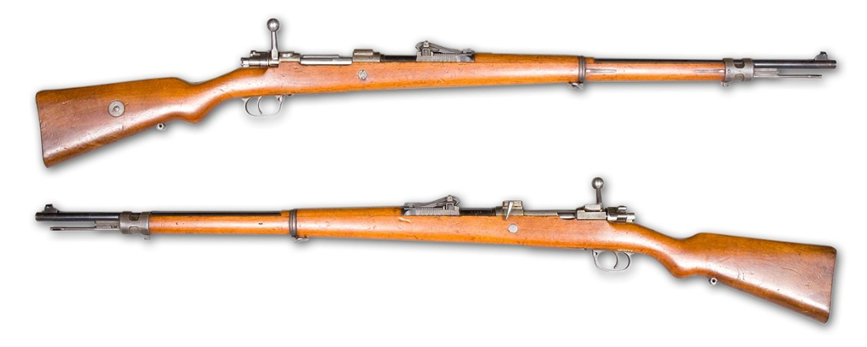
- Mauser Tankgewehr M1918
History: The world's first purpose-built anti-tank rifle, developed by the Germans in response to the appearance of British tanks. It was a single-shot, bolt-action weapon and required two men to operate effectively.
  - Caliber: 13.2mm TuF (Tank und Flieger) cartridge.
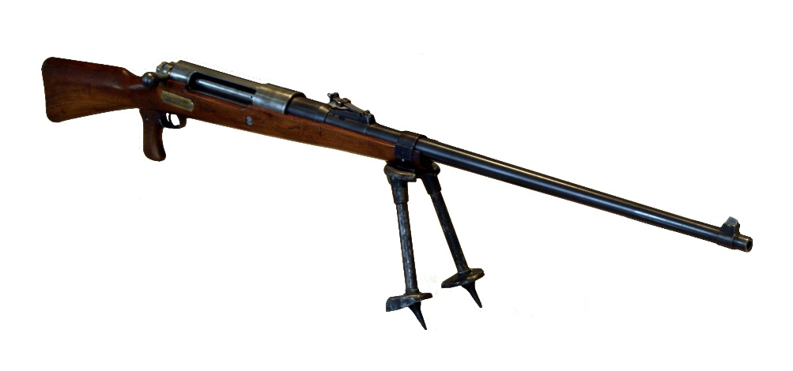

Sidearms & Specialized Weapons
- 1918 Browning Automatic Rifle
History: The Browning Automatic Rifle (BAR) was introduced late in the war to provide mobile, automatic fire for infantry while advancing in the attack (known as "walking fire"). It bridged the gap between rifles and heavy machine guns. Utilized a 20 rd. detachable magazine for rapid reloading and a folding bipod for stabilized firing.
  - Caliber: .30-06 Springfield
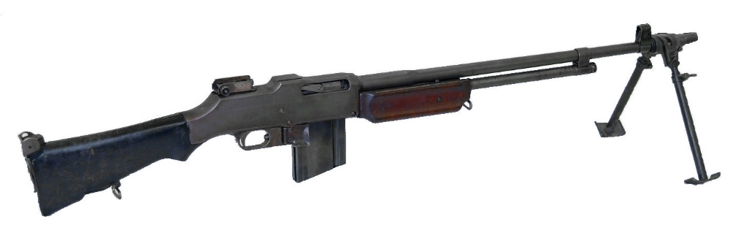
- M1911
History: The standard U.S. semi-automatic service pistol, issued to officers and support personnel. Its reliability and stopping power made it a valued sidearm in the trenches. Magazine fed with a 7 round capacity.
  - Caliber: .45 ACP
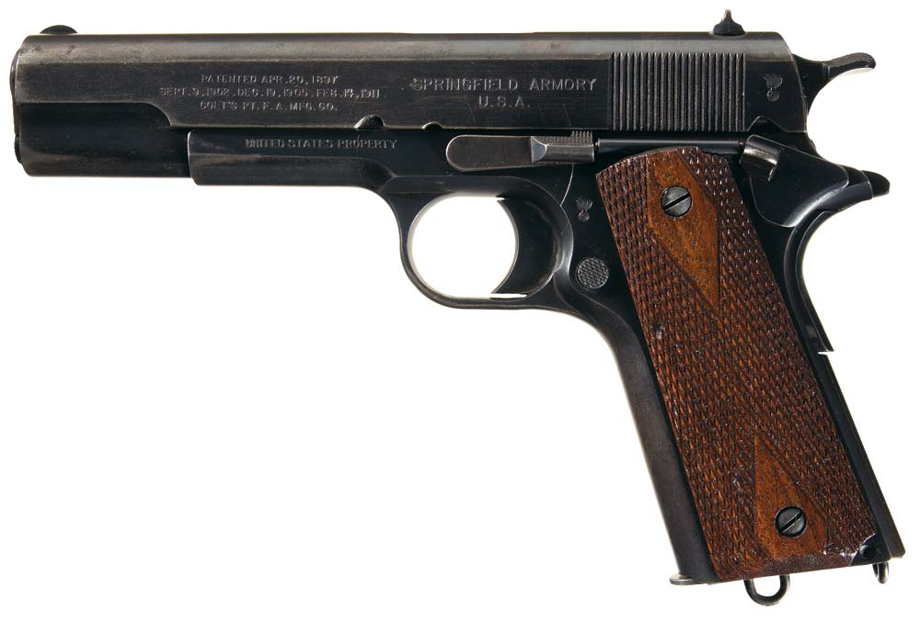

- 1917 Luger
History: While the standard P08 Luger pistol was common, the 1917 date often refers to the "Artillery" model, which had a longer barrel and was sometimes used with a stock and large drum magazine, essentially acting as a carbine. Non-“artillery” models had a shorter barrel and were magazine, vs. drum-fed.
  - Caliber: 9mm Parabellum
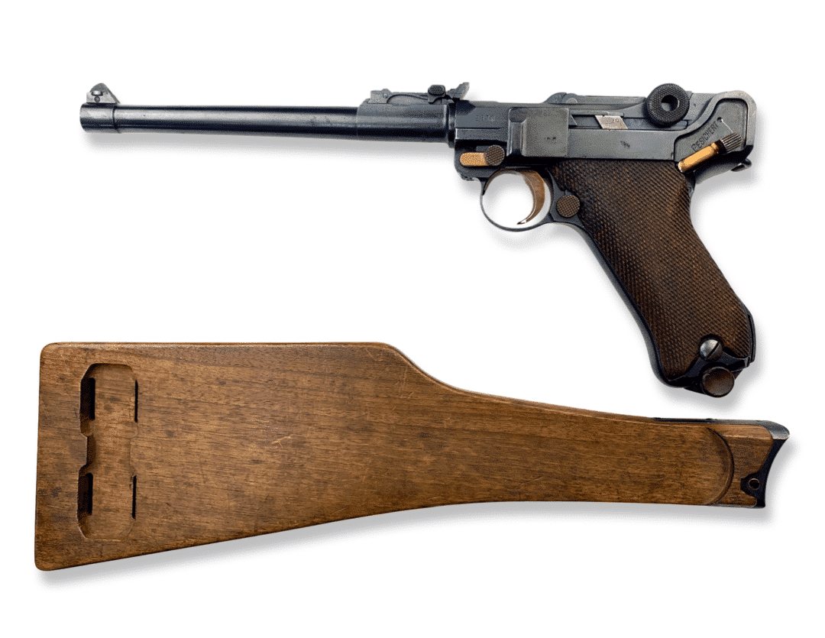
Grenades & Launchers
- Enfield grenade launcher cup
History: A simple cup-shaped attachment fitted to the muzzle of the SMLE rifle. It allowed soldiers to launch modified Mills Bomb grenades using a blank cartridge, extending their range up to 200 yards.
  - Launched a No. 36 Mills Bomb grenade using the pressure of a blank .303 cartridge.
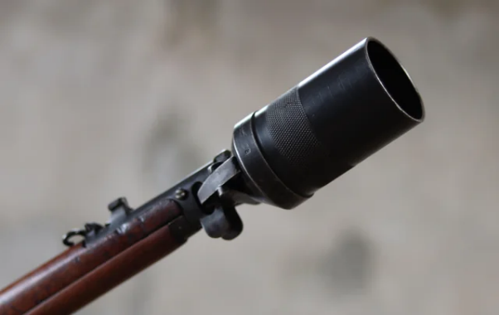
- US frag grenade
History: Most commonly referring to the Mk II "pineapple" grenade. These defensive grenades were designed to scatter lethal iron fragments over a wide area and used a time fuse.
  - Caliber/Mechanism: Contained an explosive filler (like TNT) within a cast-iron body to produce fragmentation.
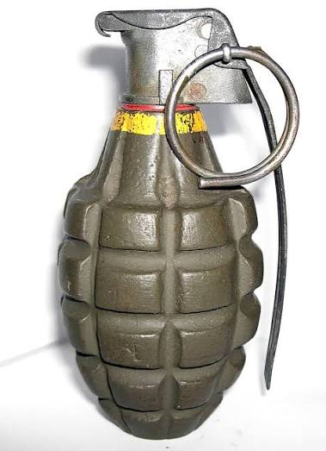
- German stick grenade
History: Known as the Stielhandgranate (stick hand grenade), nicknamed "potato masher". Its long handle provided leverage for greater throwing distance. It was an offensive grenade designed primarily for concussion/blast effect rather than fragmentation.
  - Caliber/Mechanism: Primarily relied on an explosive filler (often a mix including TNT) and a friction igniter in the handle for a blast effect.
